Bug 1 — Negative Bill Payment Amount Is Processed and Increases Account Balance
Title : ParaBank Demo|| Bill Pay || Bill Pay processes negative payment amounts and increases the customer's account balanc
Application: ParaBank Demo Banking Application
URL: https://parabank.parasoft.com/parabank/index.htm
Test account: Newly registered ParaBank test user
Feature: Bill Pay
Preconditions
A registered ParaBank user is logged in
The user has an account with a sufficient positive balance.
The account balance before the test is $515.
Valid biller/payment details are available.
Steps to Reproduce
- Log in to the ParaBank application.
- Navigate to Bill Pay.
- Enter valid information in all required bill payment fields.
- In the Amount field, enter -50.
- Submit the bill payment.
- Observe the payment confirmation/result.
- Navigate to Accounts Overview.
- Check the balance of the account used for the bill payment.
Expected Result
The application should reject the negative payment amount and prevent the transaction from being processed. A validation message should inform the user that the payment amount must be greater than zero.
Actual Result
The application accepts -50 as a valid bill payment amount and processes the transaction.
The account balance changes from $515 to $565, effectively increasing the customer's balance by $50 instead of deducting a payment amount.
Business justification: Incorrect handling of payment amounts can directly affect customer account balances and should be addressed urgently to prevent incorrect financial transactions.

Severity : Crtical
Priority : High

Shows the account balance of $515 before the transaction.
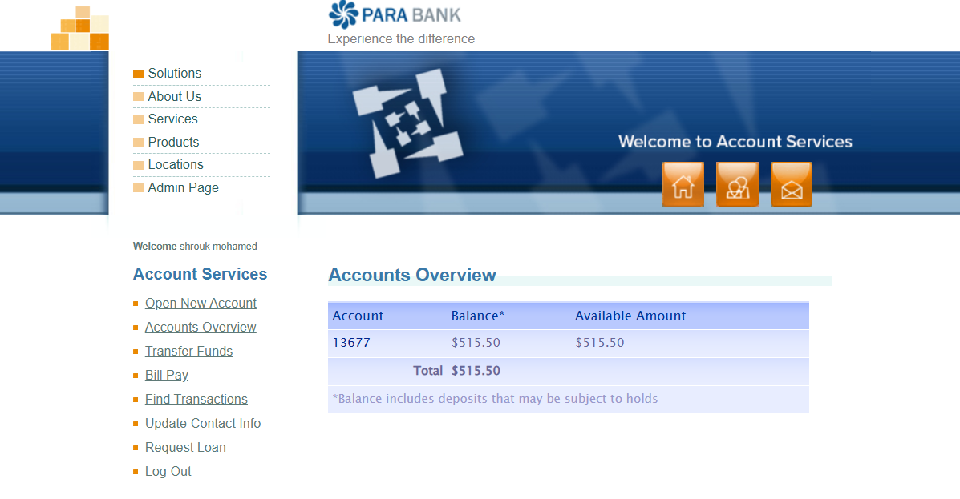
Balance After:
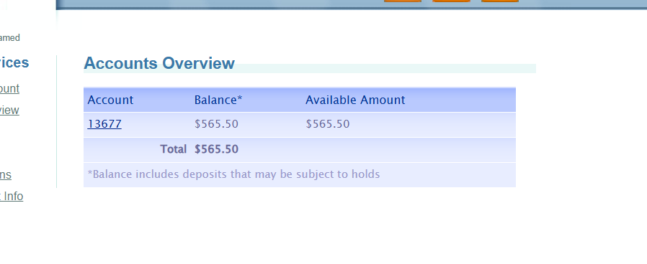
Success transaction :
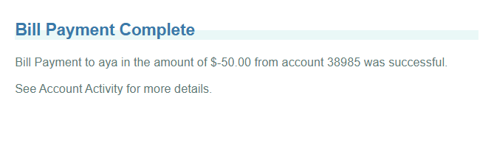 Bug 2 — Registration Accepts and Stores Alphabetic Characters as a Phone Number
Title ParaBank Demo|| User Registration / Update Contact Info ||Registration accepts alphabetic characters in the Phone Number field and stores them as the user's phone number
- Application: ParaBank Demo Banking Application
- URL: https://parabank.parasoft.com/parabank/index.htm
- Feature: User Registration / Update Contact Info
Preconditions
- The user is on the ParaBank registration page.
- The username used for registration is unique and has not been registered previously.
Steps to Reproduce
- Open the ParaBank application.
- Navigate to Register.
- Enter valid values in all required registration fields.
- In the Phone field, enter alphabetic characters, for example: abd.
- Complete the remaining required fields with valid data.
- Submit the registration form.
- Verify that registration completes successfully.
- Log in using the newly created account.
- Navigate to Update Contact Info.
- Check the value displayed in the Phone field.
Expected Result
The application should reject alphabetic characters entered in the Phone field and display a validation message, preventing invalid phone-number data from being submitted and stored.
Actual Result
The application accepts abd as the Phone value during registration.
Registration completes successfully, and the value abd is persisted and displayed as the user's phone number under Update Contact Info.
Business justification: Although the defect does not directly prevent account creation or cause an immediate financial loss, invalid contact data can affect customer communication and data quality and should be corrected

Severity :Medium
Priority :Medium
Evidence
Shows the Phone field populated with abd before submitting registration.
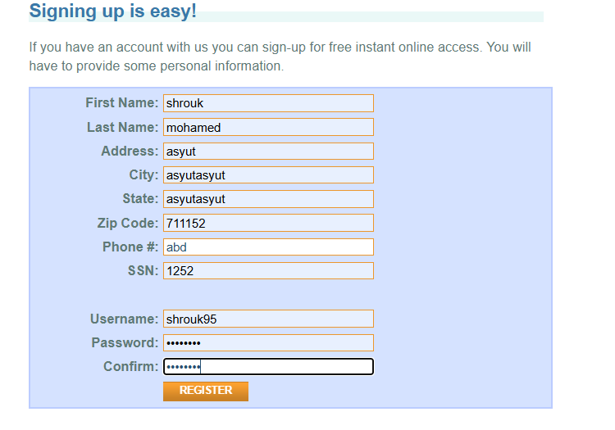
Shows that the registration completed successfully despite the invalid phone value

Screenshot 3 — Update Contact Info
Shows that abd was persisted and appears as the user's phone number after registration.
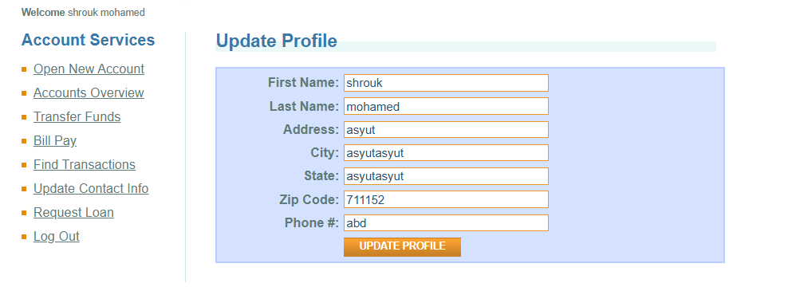

2.2 Exploratory Testing Approach
I used a risk-based exploratory testing approach, focusing first on areas that could directly affect customer data, account balances, and financial transactions. I started by registering a new test user and reviewing the Accounts Overview to establish a baseline for the available accounts and balances.
I then explored the main banking workflows, with particular attention to Bill Pay, Transfer Funds, Open New Account, because these features contain important business rules and can change account or transaction data. I used both valid and invalid boundary/input values to observe how the application validates user input and handles financial operations. I also checked whether actions that were accepted by the application were correctly reflected in the resulting account data.
This approach led to two distinct functional findings: negative bill payment amounts were processed and increased the account balance, and alphabetic characters were accepted and persisted in the Phone field.
If I had two additional hours, I would continue with deeper state-based testing of Transfer Funds and Request Loan, focusing on boundary values, insufficient funds, zero/negative amounts, account-to-account consistency, and whether successful transactions are correctly reflected in balances and transaction history

